Adegas Triay
Mencía 2018

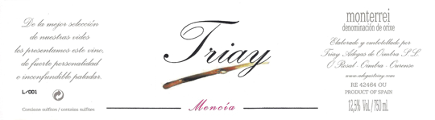
Adegas Triay is located the D.O. of Monterrei in the small village of Oimbra, right on the Portuguese border in southern- most Galicia. This small family winery is now run by Antonio Triay and his wife Puri, whose family owned the parcels of vines that now form the backbone of the estate’s vineyard holdings. Antonio’s father-in-law, Isaac García is still quite active, helping out in the vineyards and cellars. “Production here is very small, but the wines are riveting, with great purity and complexity.”

Bottle Size: 750 ml x 12
Varietals: Godello with 5% Treixedura
Vineyard characteristics and location: Located on the slopes of Ladario Mountain, the estate contains two principal soil types: Granitic, formed by the degradation of granite rocks over millions of years, it has a low pH, suitable for Godello, giving the wines minerality and brilliant acidity.
Viticulture: The vines are carefully tended by hand using sustainable vineyard practices. The harvest is carried out manually, over the course of several weeks due to variations in varietal, slope and elevation of the vineyards.
Vinification: Fermentation takes place at the estate under controlled temperature with native yeast in stainless steel tanks. Wines are naturally stabilized in the cellar.
Alcohol: 12%
Reviews:
Antonio blends a small amount of Albariño and Treixadura into his Godello bottling (five percent each), and includes ten percent Tempranillo in his Mencía bottling. Production here is very small, but the wines are riveting, with great purity and complexity, and Adegas Triay is destined to be one of the stars of Galicia in the years to come. – John Gilman, View From The Cellar

SPANISH ARTISAN WINE AND SPIRITS GROUP
GERRY DAWES SELECTIONS
WWW.SPANISHARTISANWINE.COM

